

**AITEL EXAMINATIONS BOARD**

**END OF TERM 1 ITEM ASSESSMENT**

*Uganda Certificate of Lower Secondary Education*

**S.3 MATHEMATICS**

Paper 1

**2 HOURS**

**INSTRUCTIONS TO LEARNERS;**

*This paper consists of Two Sections,* ***A****, (40 marks) and* ***B,*** *(30 marks).*

*Attempt* **ALL** *items in Section* ***A*** *and Any* **TWO** *items in* ***B****.*

*Write in dark blue or black pen.*

*Graph papers may be provided.*

***TURN OVER***

**SECTION A**

**(Short response question)**

1. At Elijah’s enterprise, a company that makes books. A machine produces the least number of books per turn, that enable packing in boxes in equal numbers of 24, 30 and 32 without any book being left out. On a given day, a school made an order of 1440 books. Determine the least number of turns the machine has to make in order to supply the school. (4)

1. Mutebi had UGX.750,000 on his account and he wanted to buy a Washing Machine. He went at the shop and the price of the machine was UGX.960,000. He went home and waited. One month later, the price was decreased by 15% and then 9% in the second month. Was Mutebi able to buy the Machine after the decreases? If yes, was he able to remain with any balance.

(4)

1. Omara went to the hospital and he was given a certain number of tablets of Panadol, Paracentam and Piroxicam to take starting from the morning.



**2**

**X**

**3**



***Panadol***



**3**

**X**

**2**



***Paracen***

***tam***



**2**

**X**

**2**



***Piroxicam***

He took his first doze in the morning and given more tablets equal to those he had remained with in order to complete a dozen of 20 tablets.

* 1. Identify the number of tablets Omara took in the first doze.
  2. If **t** represents the number of tablets he was given first, form an equation representing the above information hence find **t.** (4)

1. Mr. Kamukama’s farm is divided into four paddock fields. The area for each paddock is represented in square metre as shown in figure below

|  |  |
| --- | --- |
| ሺ𝟐𝒙 + 𝟏𝟎ሻ 𝒎𝟐 | ሺ𝒙 + 𝟓ሻ𝟐 𝒎𝟐 |
| ሺ𝟐𝒙 − 𝟖ሻ 𝒎𝟐 | ሺ𝒙𝟐 + 𝒙 − 𝟐𝟎ሻ 𝒎𝟐 |

Identify the length and the width for the farm in terms of *x.* (4)

1. Kato is a brother to Hellen, Sharon, and Christine. Using the relation “is a brother to”, draw an arrow diagram relating Kato to his three sisters. Is the relation a function? Justify. (4)

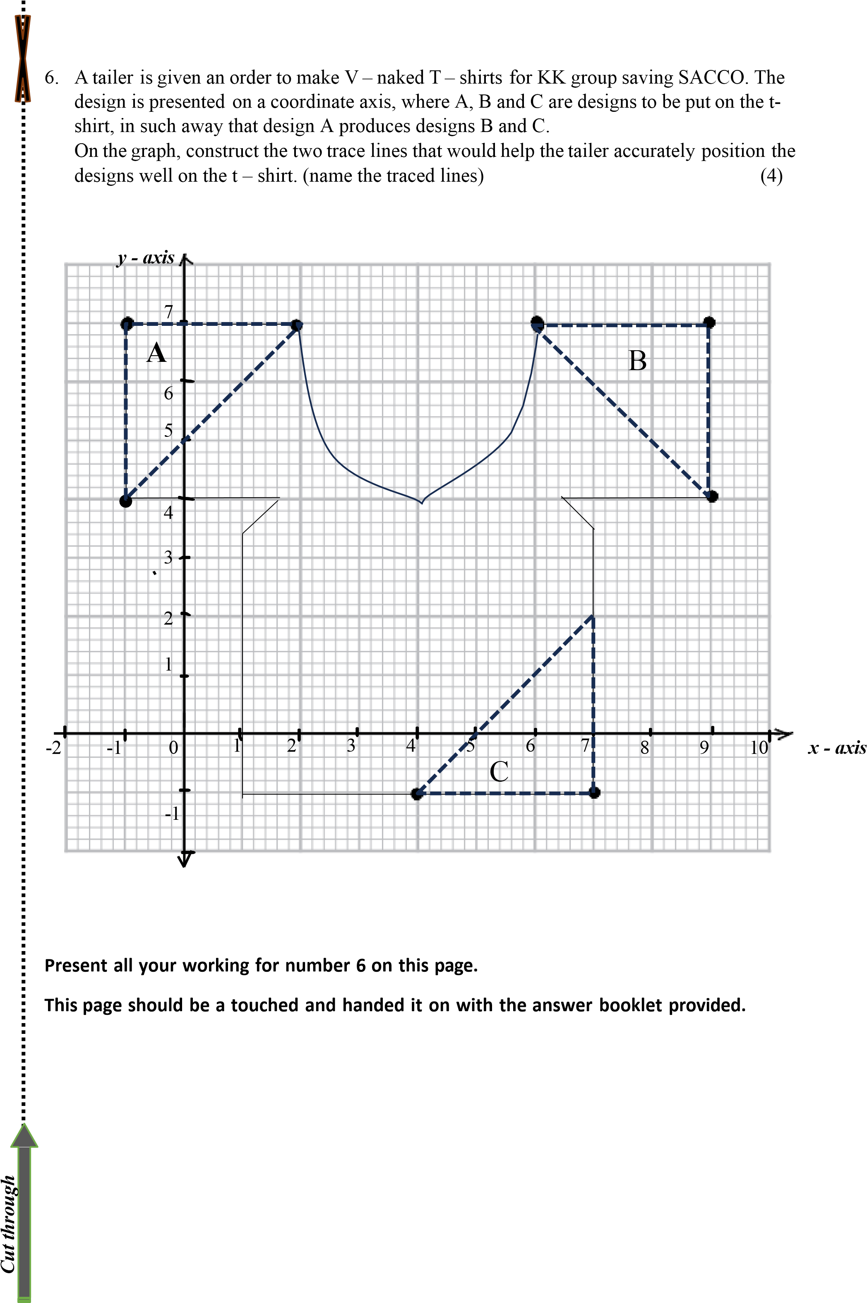

1. The population of Uganda is estimated to be the fastest growing population in Africa. It is estimated to be increasing by over 1,340,000 people every year Since 2020 whose population was estimated to be 49,718,000 people. The research team finds it difficult to present such big population values in 2020 and 2022 on a chart. Advise the search team on

some other way they can present these big population values in a reduced way without changing the meaning. (4)

1. Kevin’s goal is to find a job that provides an income of at least 40 million a year. A glass mart company offers Her a job paying a basic salary of 12 million a year plus a commission of 6% of her sales. Determine what Kevin’s total sales will need to be for her to have a yearly

income greater than or equal to 40 million. (4)

1. An engineer standing on a ramp at (400ft, 300ft). the ramp rises 195 feet over a horizontal distance of 3000 feet to reach the top car parking yard.

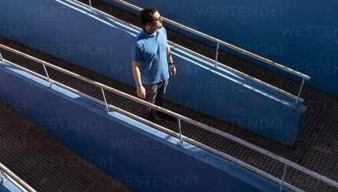

Determine the equation that would help the engineer know the displacement for any other

position on the ramp. (4)

1. Kimera bought a suit at UGX.490,000. He wishes to sell it at UGX.495,000 cash. Every customer wanting to buy it have less money than the cash price Kimera want, yet Kimera is in need of an emergency money of UGX.50,000. He wants in 7 months to have sold this Suit.

As a learner who studied business mathematics, advise Kimera. (4)

**SECTION B**

**(Extended response item)**

1. Kasomba is a farm manager at Ngori production ltd. He has a task to buy fencing material to make a rectangular partition of an area 450m2 for cabbage production. The material is meant to cover three sides, since the other is already fenced with live fence.

It has been confirmed a metre require fencing material at a cost of UGX.2000. Kasomba is given UGX.120,000 which is the exact amount needed to buy the fencing material for the three sides.

* 1. Advise the farmer on how to choose the length and width of the partition to achieve his objective. (10)
  2. The manager uses a rectangular piece of card measuring 30 cm by 24 cm to make an open box he would use to pack the produce.

The net of an open box is made by removing a square from each corner of this piece of card.

Each

square

that

is

removed

has

side

x

cm.

The

area

of

the

net

is

576

cm

2

*x*

*x*

(

i

)

Form

an

equation

in

*x*

and

solve

it

to

find

the

value

of

the

height

of

the

box.



*x*



30

cm



*x*



30

cm

(ii) Determine the length and the width of the box. (5)

1. In the press release by the Uganda bureau of Statistics, presented all Items Index and related Annual Inflation rates for 3 major components, between February 2015 – February 2016. The Annual Food Inflation decreased to 10.1 per cent for the year ending February 2016 compared to 12.8 per cent recorded for the year ended January 2016. On the other hand, the Annual Non- Food Inflation increased to 6.7 per cent for the year ending February 2016, compared to the 5.8 per cent recorded for the year ended January 2016.

Key Drivers for higher Non-Food inflation were Transport (10.7 per cent), Clothing and Footwear (13.1 percent) and Miscellaneous Goods and Services (6.3 per cent).

The table below presents a summery for the rated annual inflation.

|  |  |  |  |  |  |  |  |  |  |  |  |  |  |  |
| --- | --- | --- | --- | --- | --- | --- | --- | --- | --- | --- | --- | --- | --- | --- |
| **Year** | |  |  |  |  |  | **2015** | |  |  |  |  | **2016** |  |
| **Month** | | FEB | MAR | APR | MAY | JUN | JUL | AUG | SEP | OCT | NOV | DEC | JAN | FEB |
| **Rated**  **inflation (%)** | **Food** | 2.0 | 3.2 | 0.6 | 8.0 | 6.4 | 7.2 | 6.4 | 8.8 | 12.4 | 13.2 | 13.6 | 12.0 | 10.6 |
| **Non - food** | 4.4 | 4.8 | 5.2 | 4.4 | 3.2 | 6.0 | 6.4 | 7.2 | 7.2 | 7.6 | 8.0 | 7.2 | 7.8 |
| **Headline** | 3.6 | 4.0 | 6.0 | 6.0 | 6.4 | 6.8 | 7.2 | 8.4 | 7.8 | 8.0 | 8.8 | 8.6 | 8.4 |

Source: Final press release feb.2016

As a learner of mathematics, help the community members who a less educated to trend inflation rate with the help of a graph.

Identify the month the registered a high food inflation rate and give reasons. (15)

1. The small individual farmers in a certain village are being cheated by the traders from towns by offering them low prices for their produce. These farmers decided to form groups and sell their produce through them at better prices.

So far, they have two groups, Kamukamu and Tweziimbe. In the current season, they are selling milk, maize grain and beans. Last month, Kamukamu group had sales of 2,520 litres of milk, 35 bags of maize grain and 10 bags beans. Meanwhile the Tweziimbe group had sales of 2,314 litres of milk, 41 bags of maize and 9 bags of beans.

This month, the Kamuka group had sales of 3,254 litres of milk, 42 bags of maize and 8 bags of beans while the Tweziimbe group managed to sell 2,719 litres of milk, 32 bags of maize and 11 bags of beans. The price for 1litre of milk, 1kg of maize and 1kg of beans is UGX. 700, UGX.1,000 and UGX.3,500 respectively. A bag of maize and beans is estimated to have 120kg each.

Organize the information for the two periods and use it to determine the total sales of both groups. (15)

1. Kaira prepared a birthday party at her home and invited her friends between the age of 20 to 54 years. She wanted to confirm which age bracket mostly could attend her party. So, she grouped them starting with (20 – 24) years. The people attended were of age,

|  |  |
| --- | --- |
| 30 22 38 25 41 37 33 40  39 38 51 32 48 34 43 24  25 31 37 43 23 46 36 47   1. 44 26 36 37 41 29 32 2. 38 42 31 49 28 54 35 |  |
| Make a clear explanation for the people attendance to the party. | (15) |

**END**